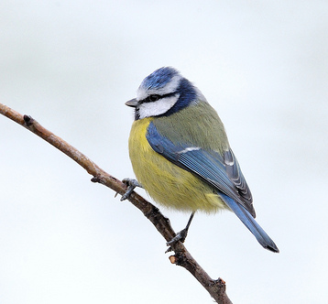  Kaskabeltz | 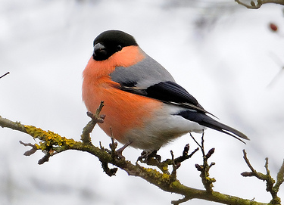  Gailupa
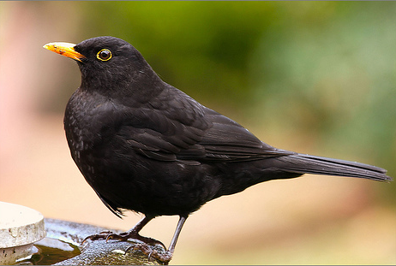  Zozoa | 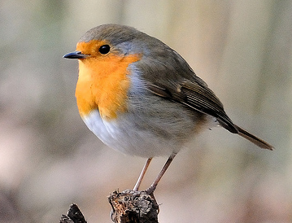  Txantxagorri
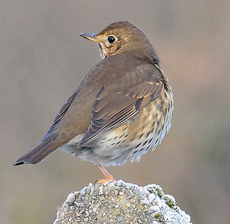  Song thrush | 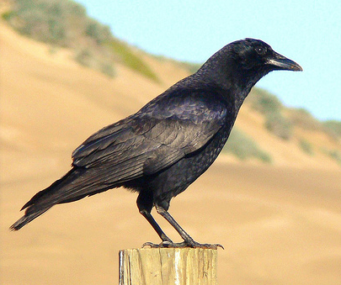  Bele
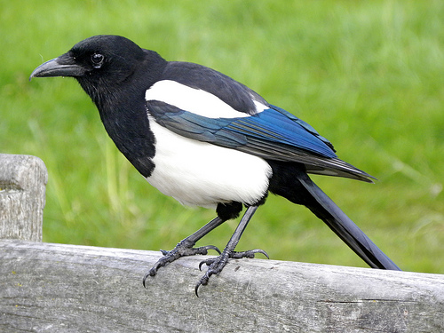  Mika | 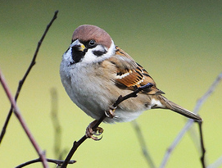  Txolarre
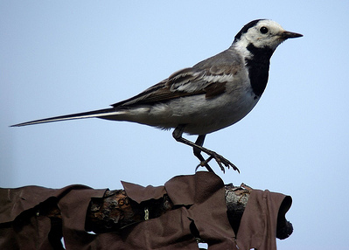  Buztanikara | 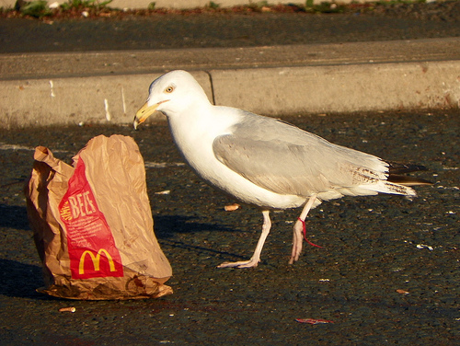  Kaio
Name: Date:
Look at the pictures of the birds. Write the names of the birds next to the sentences they match below.
Beaks
Some birds with yellow beaks are:

Some birds without yellow beaks are:

Patterns/colours
Some birds with patterned or coloured feathers are:

Some birds that are plain are:

Sorting birds: beaks
Look at the pictures of the birds. Write the names of the birds in the group that they belong in.
Short and thick | Long and pointy

Sorting Birds: Appearance
Look at the pictures of the birds. Write the names of the birds in the group that they belong in.
Black or white | Colours

Image credits
Blue tit: © 2010 Kev Chapman (chapmankj75)
http://www.flickr.com/photos/25553993@N02/5346574585/in/set-72157624267909164/

Bullfinch: © 2011 Kev Chapman (chapmankj75)
http://www.flickr.com/photos/25553993@N02/5346575467/in/set-72157624267909164

Robin: © 2011 Kev Chapman (chapmankj75)
http://www.flickr.com/photos/25553993@N02/5555884103/in/set-72157626334585058

Song thrush: © 2010 Kev Chapman (chapmankj75)
http://www.flickr.com/photos/25553993@N02/5278048691/in/set-72157624267909164

Sparrow: © 2011 Kev Chapman (chapmankj75)
http://www.flickr.com/photos/25553993@N02/5346577905/in/set-72157624267909164

blackbird: © 2008 Dave-F http://www.flickr.com/photos/frield/2349880794/

wagtail: © 2008 Sergey Gabdurakhmanov
http://www.flickr.com/photos/gabdurakhmanov/3635257869/

crow: © 2009 Linda Tanner (goingslo)
http://www.flickr.com/photos/goingslo/3536164451/

herring gull: © 2011 anemoneprojectors (Peter O)
http://www.flickr.com/photos/anemoneprojectors/5702449543/

magpie: © 2010 Rev Stan
http://www.flickr.com/photos/revstan/4653975918/

