INTRODUCTION ACTIVITY

Activity 1
Title | WE ARE INVESTIGATORS
Type of activity | Introduction / school trip
Explanation | On the trail of nature, we are going to visit Val Müstair biosphere reserve. Once we are there we will investigate where we are, what we can see and act like investigators. We will have to gather information as experts and come to our conclusions. Teachers will guide the students with some questions if they get stuck. Questions such us:  - Can we see animals? What types of animals can we see? And flora? Are there trees? Plants? Which ones? Has anyone seen any waterfalls? Mountains? What are they like? Why do you think they are there?  We motivate students by arousing their curiosity. All information will be collected in our investigator file. Afterwards, we will collect all the files and create our own collection of information.
Timing | School day
Resources | Investigator file  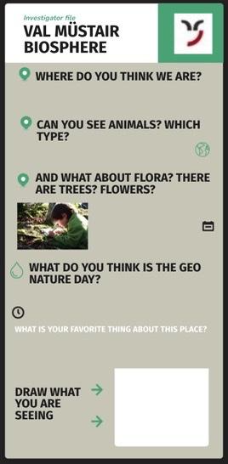  Possibility to visit the reserve with a group of students  Human resources: Four teachers
Grouping | All the class together
Attention to diversity | Before the trip, we will talk to the student to explain the importance of the visit and highlight the interesting aspects that can capture their attention and thus increase their motivation on the subject.  We will divide the visit in moments in which they will have to do short activities and moments in which they will have free time in which to rest, free themselves so they don't lose interest. Moreover the registration form we use is visual and requires short answers.

